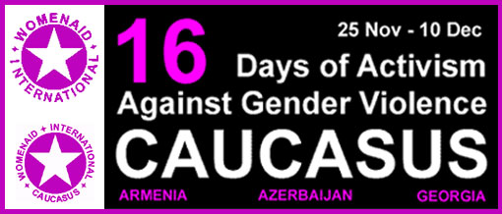
In June 1991, the Centre for Women’s Global Leadership (CWGL) together with 23 women from 20 countries - all participants of a meeting on Women, Violence and Human Rights, called for a global campaign of 16 Days of Activism Against Gender Violence.
Since that date over 800 organisations in more than 90 countries have participated in the annual global campaign, ‘16 Days of Activism Against Gender Violence’ which calls for the elimination of all forms of violence against women.
In 2000 this annual сampaign celebrated its tenth year. The 16 Days of Activism Against Gender Violence runs from 25th November to 10th December and highlights the following:
November 25, the UN International Day for the Elimination of Violence Against Women, commemorates the politically active Mirabal sisters who were brutally murdered by the Trujillo dictatorship in the Dominican Republic in 1960.
December 1 is World AIDS Day.
The twin pandemics of HIV and AIDs are decimating communities globally. Women are more susceptible to infection and are infected at a faster rate than men.
December 6 marks the anniversary of the 1991 ‘Montreal Massacre’, when a man shot and killed 14 women engineering students for "being feminists".
December 10 is recognised as International Human Rights Day.
In 1948, on 10 December, governments acknowledged the human rights of all to "life, liberty and the security of person...without distinction of any kind," as they signed the Universal Declaration of Human Rights.

CAUCASUS 16 DAYS

REGIONAL COORDINATION COMMITTEE

REGISTRATION FORM

РЕГИСТРАЦИОННАЯ ФОРМА
РЕГИОНАЛЬНОГО КООРДИНАЦИОННОГО КОМИТЕТА ПО КАВКАЗСКИМ 16 ДНЯМ

Name/Имя:

Position/Должность:

Organisation/Организация:

Address/Адрес:

City/Город:

Country/Страна:

Tel/Fax:

Email/Эл.Почта:

Website/Веб сайт:
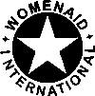

Caucasus 16 Days regional Focal Point:
WomenAid International-Caucasus:
17 Khvichia St. Tbilisi 380060 Georgia Tel/Fax: (995 32) 37 92 70

Email#1: waigeo@access.sanet.ge
CAUCASUS 16 DAYS FOCAL POINT:
17 Khvichia St. Tbilisi 380060 Georgia

Tel/Fax: (995 32) 37 92 70
Email: waigeo@access.sanet.ge
http://www.womenaid.org/16days
Email#2: caucasus16days@womenaid.org

Caucasus 16 Days website can be visited at
http://www.womenaid.org/16days

